AI project design
This project will be the first of many in my experimentation on the different software development methodologies. The goal for this project is to understand each methodology, how they should be applied and make interesting projects as an end result. I have 4 different projects lined up that I will apply different methodologies to. I want to demonstrate my thought process throughout the development to help understand patterns in my methods of programming and adapt to a more professional style of development. After each project, I will go into what I learnt and improved on.
Due to my interest in AI / NNs, my first project will be focused on an AI that can recognise different numbers in images, my design for this project will be written here. I will also be challenging myself with this project in an attempt to improve my mathematical understanding of neural networks, I will not be using any libraries to make the calculations easier such as NumPy or Torch - I will have to program each individual calculation and use 2d arrays as matrices. Without further ado, lets get into the first part of the project - The methodology.
There are 4 methodologies that I will choose from, each with their own boons and flaws. These have been written by my own understanding from computing A level and will serve as a set of rules that I will follow for each following project that I link to a methodology.
- Waterfall is split into stages: analysis, design, implementation, evaluation, maintenance. Each stage “flows” down from the last with very little chance of going back, starting with a feasibility study in analysis. This method is great for splitting between team members and managing time as everything is planned down to the individual days in extreme cases. This method does have its issues though. because its rare to go back a stage, the final project is not guaranteed to be satisfactory to the client and it can be costly for businesses to go back.

- Spiral is typically seen as a guardrail for other methodologies, in this case, I will treat it as its own. Spiral is document focused, but in a much different way than waterfall. The focus of spiral is to reduce risk by creating an initial risk analysis document, the project will then attempt to avoid these risks at all costs. Unlike waterfall, it is very iterative, literally spiralling. It follows the stages of waterfall (excluding maintenance) instead doing smaller parts of the project in a single cycle, these cycles are then repeated until a final project is completed. This fixes the issue of waterfall in that the result may not meet the clients requirements but instead causes issues with time as the amount of cycles is completely variable per project, causing cost issues for companies. The risk analysis is crucially important, if incorrect or insufficient, the project will suffer greatly. It is very suited to large projects

- Rapid application development focuses on the creation of prototypes iteratively. In RAD, incomplete requirements are initially gathered from the client to create a prototype. The client provides feedback and a new prototype is made. This is repeated until completed. This is great for clients who don’t have a complete idea of what they want the end product to be but can be difficult as it requires constant communication with the client, making it not very efficient for larger scale projects.

- Finally, agile development. Agile development is a group of methodologies, so we will follow the typical features of agile. Agile focuses on the idea that requirements shift as the project is developed, focusing on creating versions of the project – with a focus on code quality. The project is built in iterations called sprints, where each team will be given a focused goal to work towards. This is repeated until the project is completed. This system is very flexible but can be difficult to control when it gets out of track.

Now that we have all of the methodologies down, its time to actually consider which is well suited to our AI design. Currently, I can see two clear options for the project - Spiral and waterfall. Waterfall will allow for the project to be broken down very nicely, making programming much easier. Spiral is more complex, however the risk analysis will fit perfectly with a complicated concept like AI. Personally, I would like to try spiral methodology. I feel as if it would be best suited to this project as it is so risky, it is also most definitely a large undertaking.

Risk Analysis
This is my first attempt at making a risk assessment ever, therefore it is highly likely to have several flaws. To help in designing this assessment, I will split up risks into a multitude of subheadings
Personal
- May lose motivation at sight of little process
  - Set clear goals, the project will be split up into iterations so ensure that after each iteration there is a clear understanding of what the project should look like
- may be overwhelmed due to the large undertaking
  - taking breaks from the project is fine at any point if it becomes too stressful, this can either be shelved or put on hold temporarily. My mental health comes first
- may struggle to overcome complex problems and errors with the program
  - in case of an error causing me to be so lost that I overrun deadlines, I will condone the use of AI to help diagnose the problem. This is a last resort however, using AI will cause me to get a much weaker understanding from this project
Time
- may struggle to fit the project in alongside revision
  - at any point where I begin to notice a decline in my understanding of topics in school or begin to perform poorly on tests, the project should be halted immediately.
- May burn out from spending too long coding at once
  - A maximum of 1 hour can be spent on the project per day.
- May struggle to fit the project in a monthly timeframe as originally planned
  - The project will be split into different iterations with their own deadlines and timeframes to ensure that I stay on track. In a worst case scenario, it should be fine to work into next month
Understanding
- I currently have no understanding of biases in NNs
  - Before the project begins, this is the first thing that should be researched. Not using biases was fine for simpler projects, yet I am sure they can be of help in a project like this
- Misunderstanding backpropagation could lead to a model that does not train at all
  - Research into all backpropagation formulas should be undergone before the project begins
- May struggle to implement matrix maths with only basic python utilities
  - Frankly, I believe this is a very low chance of happening as long as basic research is undergone into aspects I understand less / aren’t covered in my further maths course. However, in a worst case scenario, I can just use the basic packages I normally would and scrap the aspect of the program that doesn’t use packages
- May struggle to turn images into a matrix format that can be trained with
  - This is a large issue; I currently only have a barebones idea of how I will handle this. research will need to be taken into packages that can compress images into smaller sizes and pick colours from them to be placed into matrices. This will be covered more in the design stage
Misc
- may design project too big
  - this will have to be considered in the design phase. The basic rule is that it needs to be possible to implement within a singular month
- may need better performance than my laptop can give
  - I will research into ways of offloading programs to the GPU or limiting the resources that python can use.
- will need a large amount of training data
  - it will have to be decided later in the project if this is a reasonable fear or not. If the estimated number of images required for each number goes too high that I cannot feasibly handle it, I will likely reduce the number of numbers that the program can recognise.
- NN may need too many layers / take too long to train
  - For both of these issues I am fine leaving the project as a proof of concept instead of being fully functional in case of these occurring.

Summary
- Each iteration will be given deadlines with clear goals in the design phase
- Breaks should be taken if too stressed or burnt out
- An hour is allowed on the project per day at max
- A lot of research will need to be taken into the maths behind neural networks
- Research will be needed in how to turn an image into a matrix and how to reduce the load on my computer
- If the project becomes too risky / unfeasible, it should be terminated immediately

Research
I will start my research with attempting to understand biases and their use in a network
My discoveries on Biases:
- Bias is a matrix that is added on after each hidden layer is multiplied in forward propagation but before the activation function
- There is a separate bias for each layer
- Bias can be used to counter the effects of dead neurons when using RelU or sigmoid
- A bias is used to shift the matrix towards the correct threshold
- In backprop, bias changes by the error of the layer multiplied by the learning rate
And that’s basically everything, I’m quite surprised at how simple biases really are, they already perfectly fit in with my current understanding of neural networks and will certainly help make my model much better.
Next, my research on turning images into matrices
- My current plan is that I will resize the image to the size of the matrix. I will then iterate through the image and store the colour of each pixel in a matrix
- An initial search tells me that I can use the PIL module to interact with images
- Specifically, I will be interested in the image.crop() function to ensure that I have the right aspect ratio for the image
- I will also need image.resize() or image.thumbnail() to change the quality of the image
- Finally, I will use image.getpixel() to get the pixel at each point
- This does however have a slight issue, by using RGB values I will have a tuple instead of individual weights
- I originally planned to solve this by finding a method of storing colours as a single integer, but that seemed inefficient
- I found that I should be stretching the input matrix sideways by a factor of 3. This will then be multiplied by another matrix to ensure that it is of the correct size to go through the hidden layers.
In hindsight, the final solution seems much simpler than I would of originally thought. Using a matrix of such a large size does still concern me in terms of RAM usage, therefore my next piece of research will be on how to reduce this issue.
Research on reducing RAM usage
- My initial search had the repeated name of numba CUDA coming up
- This has the issue of requiring numPy arrays to work
- Due to the sheer inefficiency of using basic arrays, I will have to scrap the concept of using no additional packages
- So that I am still challenged, I will be using numba CUDA instead
Quite a disappointing realisation, however this opens up an extremely large amount of possibilities, as I do not have to treat memory efficiency with so much care.
Upon changing to numpy, I decided to check if there was an easier method to turn an image into an array of colours. Surely enough there was! By using np.array(picture) I would be able to completely skip the step of using getpixel() – which was very inefficient

this project will be split into iterations to suit the spiral methodology. We will be beginning with the design stage as I do not plan on spending much more time on analysis past this research to ensure the project is completed in time.
Currently, it is February 4th My deadlines for the iterations are as follow:
- February 11th – image to matrix software finished
- February 23rd – neural net coded
- February 28th – neural net trained
These will not however be completely set in stone. Some parts may take much shorter or longer than expected, deadlines may be shuffled around to account for this. I also understand that only giving myself 5 days for that final deadline will be tough, I aim to get the network up to 50% accuracy as a minimum but the code is the main part to target.

Design 1
Our first area to design is the image to matrix section. I will be purely working on this until it is finished.
This will be the basic flow of the program:
- Each image will be stored in a different folder according to its number
- Each of these images in the folder are named with a number to separate them, this number will be how far through the folder it is. E.g. “11” – the 11th piece of training data
- A folder is picked at random and a random image from the folder is chosen.
- The image is opened through PIL
- The image will be cropped down to an aspect ratio of 1x1.
- The image has its quality reduced to 100x100 (this may change later in development after testing)
- I use np.array() to turn the image into a matrix
- I create a new matrix of size 1x10, this will be a zero matrix except for the position of the number in the image, which will be 1. This will be the correct matrix used to train the NN
- I now have all necessary inputs
At this point, I realised I did not know how to randomise the image chosen. I decided to quickly check online for a solution and found that os would be a good module to choose for this purpose. I simply have to use os.listdir() to get all of the files in a path, I could then randomly pick a position from the returned array as I would any other.
Success criteria:
- I have 10 different folders with a picture of a different number stored in each
- I can access a random image from a random folder
- I have the ability to convert images down to a 100x100 size
- Images will be turned into a 100x100 matrix
- A correct matrix is created alongside the input matrix
The largest risk of this iteration is that I will need training data to test it. I will likely get a picture of each number just for testing, training data will need to be sorted out later after programming
Another risk is that the path directory needs to work when I upload the folder containing the program to github, meaning I cannot use directories that are specific to my computer
Implementation 1
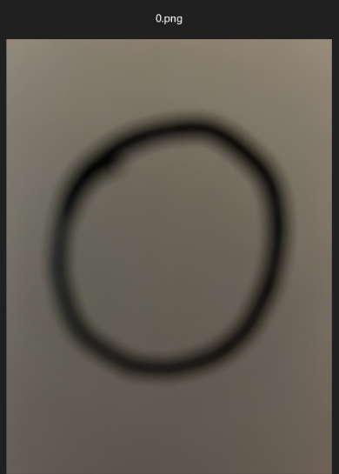
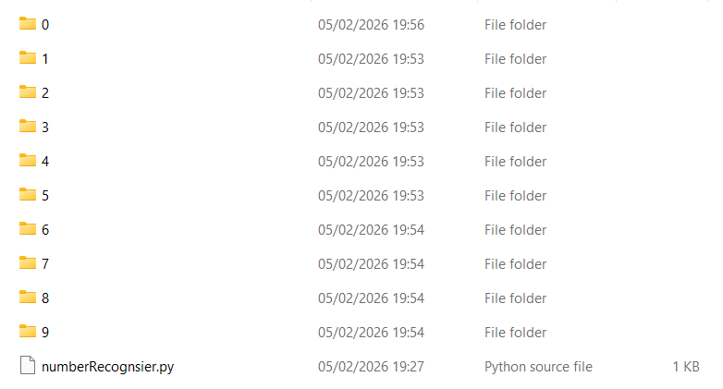
I started by creating the file layout of the project. Within each of the folders is a separate piece of training data that I made by hand.
Transferring the training data from my phone was extremely difficult as I had to make sure they were the correct data type alongside actually finding an efficient method of transferring photos. I will most definitely need to look into better alternatives for training data as this is not sustainable.

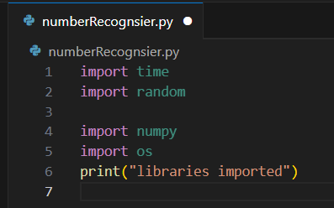
the code began with importing all necessary packages that I would need. I luckily already had these packages installed from previous projects and therefore did not need to use pip to install them. I noticed that the importing was taking a long time so decided to add a print statement at the end to be certain when it ended.
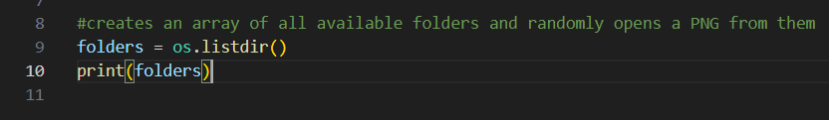
I was not certain on the output that listing the directory would give and so decided to perform a simple test with the function.
Upon first viewing this, I wanted to just remove the last item of the array to get the folders on their own. However, this would not be maintainable, I did not want to disallow myself the adding of any more files to the directory.
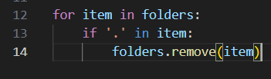
I didn’t want to go back to research in looking for a new OS function to check for folders, therefore I simply decided to remove all entries with a ‘.’ In them, as they would not be folders.

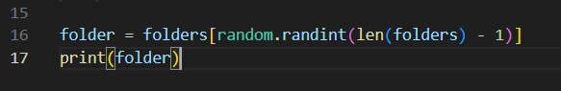

I planned to use this portion of code to pick a random folder however this returned a syntax error. I had forgotten that randint requires a parameter for the starting point. I also disliked how convoluted this code looked and so decided to clean it up slightly

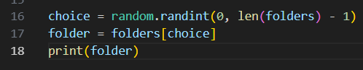

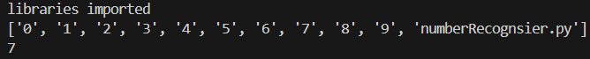

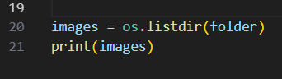
Much better!
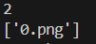
I could then use this name of a folder to get all the images inside, as expected there is only one.
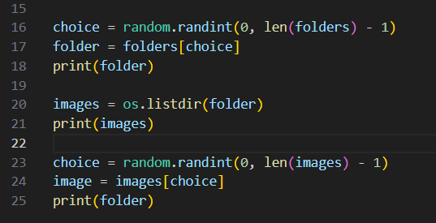
I decided to use the same approach as prior to get a random image, however just looking at the code made me see the inefficiency. I decided to implement a function to clean up the code alongside some comments.

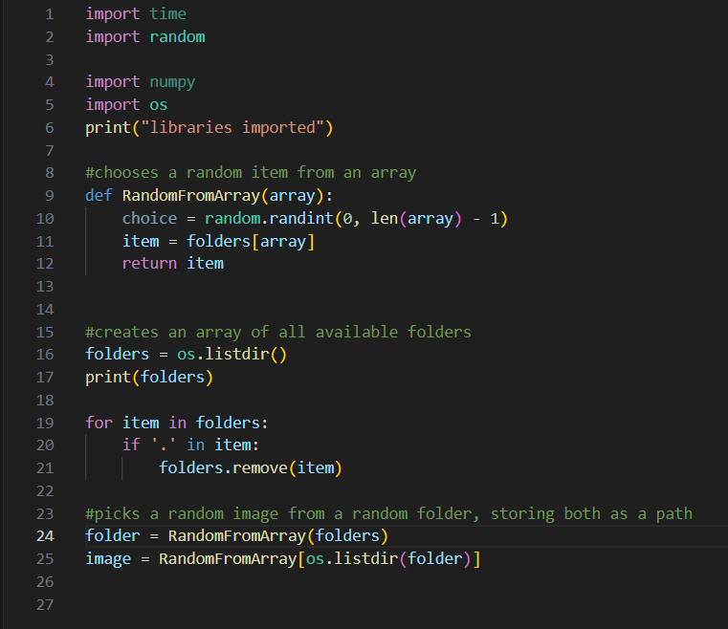

It was then that I planned to open the image file with pillow, only to realise that I had forgotten to import it. i quickly added the import for PIL as I had in a prior test program whilst researching
This was not the first time I have had issues with packages, I simply needed to add it to the path environment variable on my laptop.
This quickly revealed a large issue however, this program would not be usable for those who do not have the packages installed. Meaning I would have to install the packages in the folder with the program
I decided to add the module to the same folder as the program as this has worked for me in the past. This did cause the program to work correctly but began to cause issues with the directory. I changed the line of code for listing the directory to be more specific to fix this.
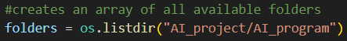
However this solution feels quite volatile, I am not certain of how the function decides what the directory is. I decided it would be necessary to look into how this function actually works.
Os.listdir() lists the “current working directory” of the program, this is typically the folder the file is in, yet by turning off visual studio to add a module and opening the whole folder instead, I caused it to have a different CWD. I can apparently use “__file__” to get the path of the file directly.
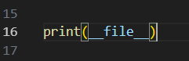
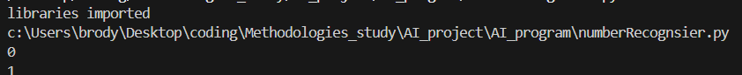
Lo and behold, it perfectly prints out the directory of my running file. I now needed to get the folder the file is running in, so I split up the address by “\\” and combined it back together without the last element.
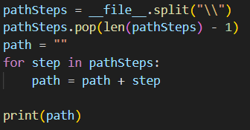

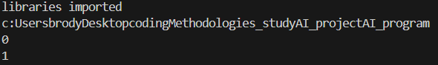

This was seemingly a simple fix of just adding the backslashes back, but I would have an extra backslash at the end of the string if I just added as is – I decided to add an if statement to make sure the item being added was not the final item
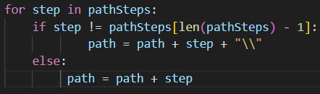
This managed to perfectly replicate the directory of the folder. I could then implement this with my os.listdir() functions I had used earlier
The directories were now fixed, but I still had to focus on options for accessing the libraries. I saw two options I could choose, I could either remove them from the random selection of folders manually. Or I could find a new solution that lets the program access the packages for future use. Out of interest, I decided to follow the latter solution and began researching.
I could apparently ensure the packages are checked for by using sys.path.append(path) I liked this solution quite a lot and decided to implement it. I would have to use the same solution for paths that I used earlier to reach the module path however, so I decided to implement another function.

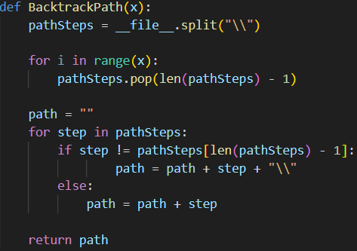

This was then used to allow the program to reach packages in the prior folder alongside cleaning up how the path variable is initialised
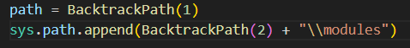

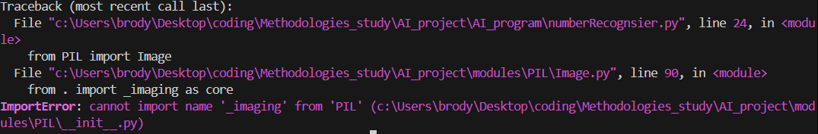
I was then quite surprised to see that this did not work. The packages had not been imported correctly and PIL returned an error

There was an additional optional method I could reluctantly use. Virtual environments, I had heard much of virtual environments in the past but never understood them. I decided to look into how they work.
I could apparently create the path with “python -m venv (path)” to create a folder structure that I could install packages into and then activate it through the activate.bat file inside of it. i decided to give this an attempt as it is seemed a much more professional method to handling packages.
This immediately worked, it was a much simpler approach and allowed me to handle packages so easily. I had never worked with GitHub before and this seemed like an absolutely incredible tool to have for future projects.
I then received another error related to my usage of the image.open() function
whilst looking through the code of PIL in an attempt to fix the error, I found an interesting comment left in the code, so I decided to give that a go.
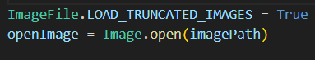
yet this did not work, so I decided to try it with a jpeg instead – which did not work either.
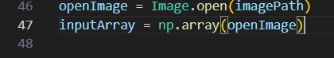
I looked online and saw that this issue was likely due to corrupted files, so decided to redownload all of my files from my phone again. As I did this I realized the likely error, I had simply renamed the image files instead of actually converting them. I used a converter online and my code finally worked without errors.
I continued to convert the open image file to the input matrix with numpy
I realised I had failed to research the necessary code to actually initialise a numpy array to use for the correct output matrix. A quick search told me to use np.array([]), but I liked np.zeros() much more as it allowed me to create the matrix with solely a size input.
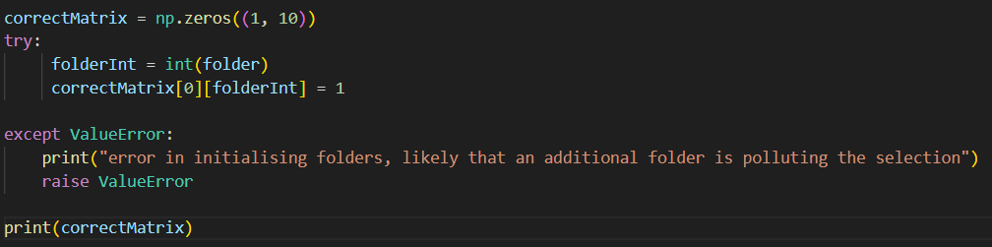
And with that final piece of code, My first section of implementation was complete. However, if it is not glaringly obvious, there was a large amount of errors in my methods of implementation. I believe it would be beneficial to discuss that next.
review of implementation 1
implementation 1 was not as bad as it could’ve been - I thought of solutions quickly and managed to work through some extremely stressful parts of coding. However, attempting to code in such a structural way has been difficult, I had never realised just how many mistakes I make subconsciously.
The largest issue that I faced was due to research, I was reluctant to search things up online throughout the implementation due to an ego that I wanted to uphold, this led to me wasting a large amount of time. In the research stage, I had not decomposed the problem enough; this led me to not using efficient code where possible, not understanding new functions and not solving issues as quickly as possible.
Then there was the issue of stress, the concept of deadlines to program in was very stressful to me. The program was finished on the 11th - the final day. This was due to intense procrastination in the first two days. And on the final day, I broke one of my rules set out in my risk analysis. I coded for 30 minutes more than allowed. This project should not be stressful, it is simply an attempt to understand my methods of coding much more.
So why am I discussing this? Its not to put down the time spent on the program or to say that I am a bad programmer. Instead its to recognise problems that I can change for the next cycle. the main things that I need to focus on during the next cycle is research and organisation.
Research:
- I will create a structure diagram in the research of the next cycle to ensure that I have covered all parts of the program
- I will create a list of all newly learnt lines of code and a short description of their usage
- I will spend much longer researching
- I will allow myself to research during the implementation
Organisation:
- Throughout the cycle, I will set planned times for each aspect of development. for example: “research finished in 3 days”. These will not be strictly adhered to but simply a point of guidance.
- I will not break any rules I set to reduce risk
With these new rules, I will now continue onto research.
(it was realised later in the project that I had also neglected my success criteria, I had forgotten to implement the feature that downsizes the image before it is turned into an array. This later had to be programmed in implementation 2)
Research 2
So, before we begin by creating our structure diagram, its time to create the planned times. (this is being written on the 14th)
Research – 3 days
Design – 2 days
Implementation – 4 days

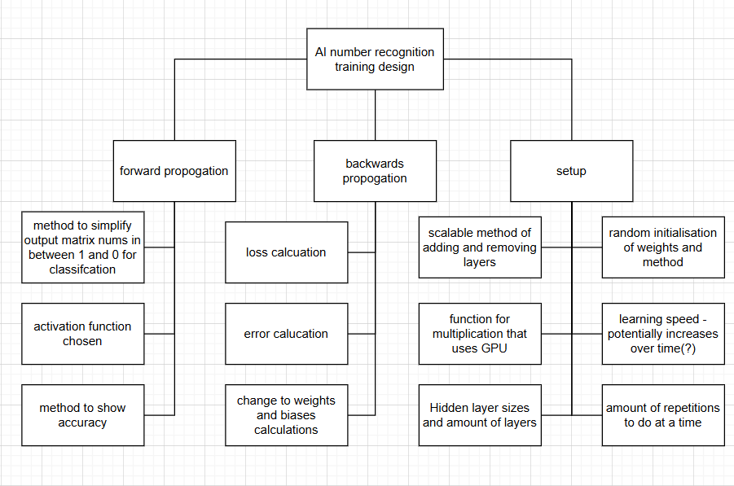
Setup
Scalable method of adding and removing layers – ive already coded a solution that uses NumPy to do exactly this. The process is that of adding each weight matrix to an array and looping through the array, multiplying each time. A function will handle the adding of an array and I can call it as many times as needed to create the layers, it is likely that I will add an extra parameter this time for the amount of layers to add to make the code much more maintainable. A separate array will be used for bias and weight matrices

Random initialisation of weights and method – I am currently aware of two types of initialisations, Xavier and He. However, I am not sure of which would be the most effective. A quick search tells me that Xavier is much more effective if my activation function is sigmoid or tanh and that He is built for RelU. I will make the decision as I choose my activation function.
The function for multiplication that I will be using is np.dot(), which is the dot product of two matrices and np.outer() which is the outer product. The much larger concern is how numba CUDA will be used to allow for GPU usage. I decided to look into it, I instead found a library called CuPy which was specifically designed for the usage of the GPU alongside NumPy. These are my notes:
- CuPy uses a different class for the creation of matrices, instead using cp.array([]), this has practically all of the same functions as np.array([]) but instead has a knowledge of the current device it is being ran on. For all future functions stated in this research, they will almost always be cp instead of np in practice.
- CuPy requires CUDA, this means that I must have a NVIDIA GPU, luckily, I do have one
- Although custom kernels can be written for the GPU, all CuPy functions are automatically designed to work more efficiently on the GPU.
- Cp.asarray() can be used to move a NumPy array onto the GPU and cp.asnumpy() can be used to move from GPU to CPU
- cp.get_default_memory_pool() can be followed by either get_limit() or set_limit() to control and monitor memory usage.
Luckily, CuPy is quite simple to implement. I will however have to install CUDA.
I will have to decide on a learning rate for the project, I have also heard in the past of learning rate decreasing over time to ensure a quick start to training and precise finish; I think that could be beneficial to look into. However, a search has told me that complex algorithms to change learning rates throughout the program are likely unnecessary. I can instead just use SGD, which keeps learning rate the same. I will however have to tune the learning rate over time, I will likely start with it as 0.01 and attempt with various other learning rates until I get a good result.
The size / amount of layers will be crucial. If I add too little, the network will not be able to adapt and will have poor efficiency. If I add too many, the network will need too much training data to train. I wanted to initially decide on the size of the input layer, therefore I downsized the same image of a 0 to multiple different resolutions to see the result


10x10
15x15
25x25
20x20
50x50

Although, I had initially only thought of an image size of 100x100, it seemed as if an image size of 15x15 and above would just as equally work. In an attempt to reduce the need for training data, I decided to use 15x15 – which would be 15x45 for the input layer due to the 3 different colours of RGB. I was not entirely sure just how many layers would be needed, and nothing online could say the exact amount my problem would take to solve.
I struggled quite a lot in finding a correct order of shapes for the matrices to get a final 1x10 due to the painfully shaped 15x45 matrix, I decided to look into alternate ways of shaping the input matrix and found the perfect solution. I would simply have to turn the image to grayscale and then I could get the input as a 15x15 with values in between 1 and 0. I disliked this method, as it meant modifying my earlier code and also went against my earlier research but I knew that It would be better for the network in the end. I simply had to use picture.convert("L") to turn the image grayscale and the rest would be handled for me, I would then divide by 255 to get values 1-0.next, I would multiply by 6 15x15 layers, flatten to a 1x225 and then multiply by a 225x10 to get the final output. To flatten, I would just use matrix.flatten() or matrix.reshape().
The training would likely use an input from the user for the amount of times to train, after the training is over, it will then output the current loss and accuracy of the last 100 attempts. That way, monitoring is made easy.
Forwards prop
I needed a function to turn all values in the final output matrix into a value in between 1 and 0, I decided to use softmax for this purpose as I have used it in the past. I would simply just apply it on the final matrix to get clean values that add up to 1. The steps for softmax are:
- 1) subtract the largest number of the matrix away from all other values (to ensure that values don’t explode)
- 2) select each number in the matrix in turn
- 3) put e to the power of each number
- 4) add up all of the numbers to a total sum
- 5) divide all numbers by that sum
An Implementation using NumPy from a previous project:
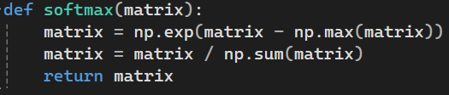
I would then get a nice set of probabilities that can be queried to get the networks final answer. I could compare np.argmax() of the predicted answer and the correct one, if they are the same, the network is correct!
Then came the choice of my activation function. In the past I tended to stick to leaky RelU, but I looked into any alternatively more efficient choices. I still found that RelU functions were the best for hidden layers in classification problems involving imaging, due to my previous experience with it, I decided to use leaky RelU.
Leaky RelU is very simple, it would multiply all negative values by 0.01, for this approach I could use np.where(matrix > 0, matrix, 0.01 * matrix)
The derivative of the function used in backprop is to set all negative values to 0.01 and all positive values to 1, for this approach I would multiply by np.where(matrix > 0, 1.0, 0.01)
As I had now chosen my activation function, I now had to choose my method of initialisation. I had already discovered that RelU is best suited to He initialisation so I decided to look into the steps of it.
- Initialise random weights
- Calculate standard deviation with sqrt(2 / rows)
- Multiply standard dev by the weights
To create random weights, np.random.randn(rows, columns) can be used. It is also important to note that biases will be created at this point.
The accuracy function will actually be very simple. There will be 2 variables, “sum” and “attempts” the sum will have a 1 added every time an answer is correct. Every time the network makes a prediction, a 1 will be added to the attempts. The average accuracy will simply be the sum divided by the attempts.
Backpropagation
I am already aware from previous projects that there are two methods to calculating loss, MSE and cross entropy. I already was aware from my notes that cross entropy was ideal for classification tasks and thus decided to use it. the formula for cross entropy for a singular item in the matrix is:
-(correct answer * log(predicted answer))
Then all items would be summed up. Luckily in numpy this can all be done at once by using np.log() and then np.sum(). I would also have to add a small number to avoid log(0) which can just be simply added with + due to broadcasting according to my research.
To calculate the error of the first matrix. I would have to use the derivative of this function, which is:
Error = predicted - correct
I already knew the formulas for error calculations and change to a matrix, but decided to confirm them online to ensure I was not making any errors. I luckily found that they were correct.
A brief explanation of backprop is that it is split into finding the error of a matrix and then the change to that matrix. The first error will be the derivative of the loss function. From that point on the following equations are used:
error=( next_error @ W^{T} )∗f′(z)
where:
- W is the weights of the current layer
- f(z) is the activation function on the pre-acc results
- next_error is the error that comes after the error you are attempting to calculate (in terms of forward prop sequencing)
- “*” represents elementwise multiplication

ΔWeights=(inputs^{T}) @ error
Weights = W – η⋅ΔW
Where:
- Inputs is the post activation result, as this is multiplied by the layer to get the next one
- Error is the error of the current layer
- η is the learning rate of the algorithm
(these were taken from my neural network notes document)
I then briefly looked into the changes to biases in backprop as I only learnt them earlier in this project yet was extremely confused to find that they apparently are only 1-dimensional matrices. I decided to investigate further…
The process with biases is to collapse the delta matrix to one dimension so that it is of size (1, n) (n being the neurons / columns of the weight matrix it is attributed to). This is done by calculating the sum of each column of the error and then subtracting that from the bias array multiplied by learning rate. This is shown in the formula below:
Δb = summedColumns(error)
b = b – η⋅Δb
I would calculate the sum of each column with the line of code np.sum(delta, axis=0)
I also found online that the error should be typically referred to as the delta of the layer or the gradient of the layer for future reference.
.T at the end of a matrix will transpose it, @ can be used for dot product, np.outer() is used for outer multiplication and * will work in python for elementwise multiplication.

Code bank
Below is all of the code that I mentioned throughout this research stage.
np.dot(a, b) – dot product of two matrices
np.outer(a, b) – outer product of two matrices
cp.array([]) / np.array([]) – creates either a CuPy or NumPy matrix.
cp.asarray(A) – used to turn a CuPy matrix into a NumPy matrix
cp.asnumpy(A) - used to turn a NumPy matrix into a CuPy matrix
A.flatten() – flattens a matrix
np.reshape(A, (x, y)) – reshapes a matrix to the stated dimensions
picture.convert("L") – turns a pillow picture grayscale
np.exp(A) – puts e to the power of all numbers in the matrix
np.max(A) – returns the largest value of an matrix
np.argmax(A) – returns the index of the largest value
np.where(A > 0, A, 0.01 * A) – will multiply any negative values by 0.01
np.where(A > 0, 1, 0) – will set all positive values to 1 and all negative to 0
np.log(A) – performs the natural logarithm on all numbers in the matrix
np.sum(A) – the sum of all values in the matrix
np.sum(delta, axis=0) – sums up all columns so the matrix is of size (1, n)
A.T – the transpose a matrix
A * B – elementwise multiplication

It was now time to move onto design
Design 2
This iteration will be focused on the creation of the actual neural network. Below is how I plan for it to work, I will not be describing how to perform any of the calculations as that has already been noted in research
Setup:
- learningRate will be set to 0.01
- a function called addLayer() will be added to the program with a parameter of size as (rows, columns). The function will then
  - create a CuPy array of the specified size
  - randomly initialise it with He Initialisation
  - append it to Weights
  - append a zero matrix of the size (1, columns) to Biases
- a function called RelU() and softmax() will be added, each implementing their own activation function. They will:
  - append the pre-activation result to preAccs for calculating the delta later
  - perform the activation function
  - append the post-activation result to postAccs for calculating the delta later
  - return the result
- another function called loss() will be added. It will simply calculate the loss of a matrix with cross entropy and return it. it will take the parameters “correct” and “predicted” (y / ŷ)
- a function called delta() will be added which will calculate the delta of every layer. The steps it will take is:
  - initialise an empty array called “Deltas”
  - compute the error of the output layer
  - append the error to Deltas
  - start at the final layer that is not the output layer, moving back a layer each loop.
    - get the index of the weight in Weights using index()
    - get the corresponding pre activation result from that layer in preAccs
    - use the first term in the Deltas array as the delta of the next layer
    - compute the delta for the layer
    - insert the delta to the front of the Deltas array
  - repeat until the length of Delta equals the length of Weights
- a function called updateLayers() will be added
  - for each layer in Layer
    - get the index of the layer and then the corresponding post activation / delta at that index in their own arrays
    - calculate the change to the weights
    - subtract the change to the weights multiplied by the learning speed from the weights
    - sum up the delta array columns and subtract from the biases
- a function called forwardPropagate() will be added with a parameter “input” (the input matrix)
  - for each layer:
    - the input will be multiplied by the weights of that layer
    - the bias will be added
    - as long as the current layer is not the final layer, Relu() will be used on the results
    - if the next weights are the output layer, the matrix will be flattened
    - if it is the final layer, softmax() will be used instead
  - the final output will be returned
training loop:
- all weights and biases will be added manually with the function addLayers() to create a “Weights” array and “Biases” array
- the program will ask how many loops to train
- set “attempts” to 0 and “correct” to 0
- for each loop:
  - create empty arrays called “preAccs” “postAccs”
  - get the input matrix and correct matrix from code in first implementation
  - append input matrix to postAccs
  - forwardPropogate() the input
  - compare the predicted with the correct answer. If correct, add one to correct
  - output result of loss()
  - delta() is used to get the delta of every layer
  - updateLayers() is used to update each layer
  - add one to attempts
- output the accuracy using correct and attempts
Success criteria:
- the network is able to make changes to the weights and biases
- the weights and biases work correctly in forward propagation without returning a size error
- the loss of the network slowly decreases over time
- the accuracy function shows the accuracy of a set amount of loops
- all individual activation functions work correctly when tested
- the network does not take up too much memory on my computer
- weights are initialised correctly
- values do not explode and final matrix has numbers adding up to 1
- the input image will be grayscale with values of the matrix made by it being in between 1 and 0
- the network can get the correct answer the majority of the time on the small data set already given
now with the learning lessons of the first implementation, it is time to make another attempt at programming with a much stronger amount of research and more specific design.
Implementation 2
I am going to start by adding the code to decrease the quality of the image as I had forgotten to add this in iteration 1. Luckily, this code had already been written in a test program in the previous iteration so it was a simple case of copying it over.
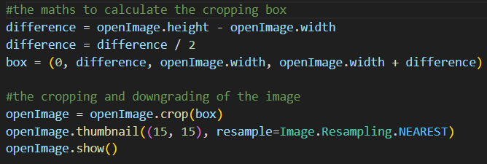
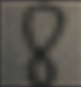
The code was written with the assumption that the image provided would be taken from a phone. And as the height of the image is greater than the width, creates a cropping box where the y coordinates are cropped down and the width remains the same. I disliked the maintainability of this approach and so decided to make the code also work if the width was the larger of the two.
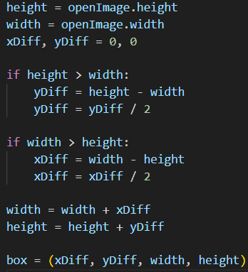
this was my first attempt, however it did not crop the images into a square. Instead leaving some space at the bottom. I figured that I would have to create the box inside the if statements to account for the different ways they are made in each scenario.

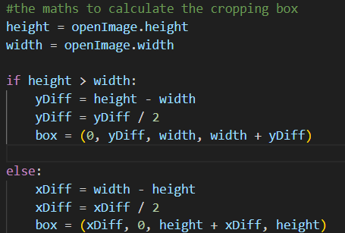

This was my updated approach. It worked for all training data where the height was larger and should work if the image already was a square. But I did not want to chance it. I rotated one of the pieces of training data and tried the code on that. It luckily worked!
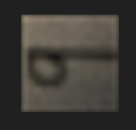
I removed the line of code to show the image and It was now time to add the greyscale feature. This was just as simple as adding the line of code from research into the program just before the image is turned into an array

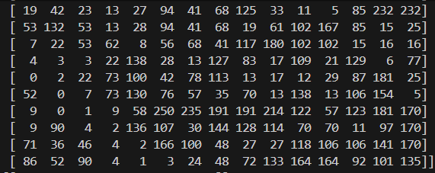

As all of the numbers were so large, I had to divide by 255 to get decimal values in between 1 and 0. The result did not look as nice but would be much better for calculations in the future.
Before I work on anything else, I decided to turn the code from implementation 1 into a function to fit the style of code planned for implementation 2. This involved some shuffling around of the code and added comments but ended up being much more maintainable as an end result.
I also needed to set up the basic training loop, due to its simplicity, it was extremely easy to add - It did however include some input validation on the amount of times to train.
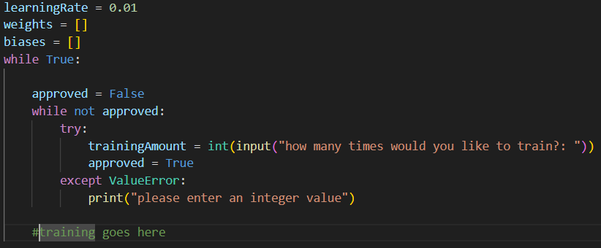
I now wanted to work on the addLayer() function, as it is a baseline for all other parts of the code.
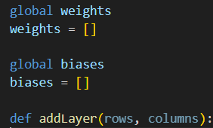
i initially started by making weights and biases global. This would make it much easier to access them inside of the function and append new layers.

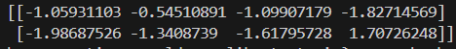
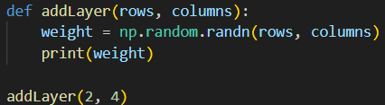
i then tested the random function to create the weights to ensure that I was passing the parameters into it correctly. I luckily was!
I could then quickly import the maths module and implement He initialisation

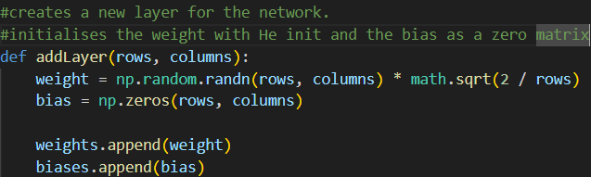
…and finish off the function.
I was ready to leave the function there but upon checking my notes I realised that I was supposed to use CuPy arrays instead. I quickly switched over to CuPy only to realise I had not imported it into my virtual environment yet.
I added the import for CuPy in my code and installed it using pip into the venv. I could now switch over all of the arrays from np to cp.
I also realised that I had written the bias initialisation code wrong. I changed the rows column in cp.zero() to 1 to ensure it worked correctly.
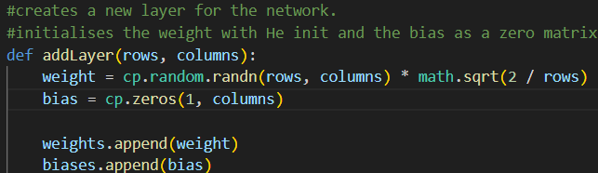
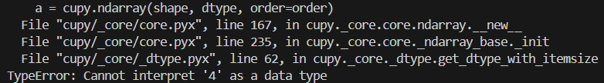
However, this code returned an error, upon looking into the parameters needed for the cupy array. I saw that it only took one “shape” at the start. So I decided to encapsulate the two parameters in brackets to make them a single parameter. This worked and allowed the program to carry on as usual.
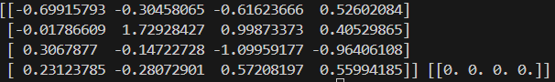
an example of the end result of the function

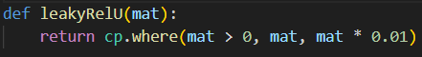
I could now move onto coding both activation functions. I chose leaky relU first as it is used the most. It was very simple to code as it only took a single line that I found in my research

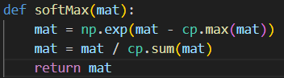
Next was SoftMax, this too was fairly easy as I had already coded it in previous projects. It should be noted that using CuPy felt very strange however. Although it is effectively the same as numPy, it was weird to effectively completely sub out numPy.

Now it was time to test each function, I coded a small snippet to do so
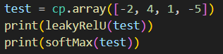

It was very easy to tell that the leaky RelU was working but I was not as sure about SoftMax, I added up all values using cp.sum() and was relieved to see that It returned 1.
Continuing my pattern of working down the list of functions in my design, i was going to work on the loss function next. But realised the difficulty that would come with testing it without a predicted answer. Thus I decided to work on forwardPropogate() next as I had all weights and biases now.
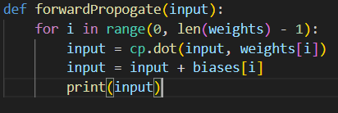
this was the basic code that I began with for the function that simply multiplies each weight in turn and adds the bias without any activation functions. I tested this first.
I found that subtracting the 1 from the length was unnecessary and caused the loop to skip the last term. I quickly fixed that and faced another error.
I assumed this meant that one array was a NumPy array whilst one was a CuPy array. I was certain that the weights were CuPy so I checked the input matrix only to find that it was NumPy, I changed it to the correct type alongside anything else that I had previously programmed using np instead of cp. I tested again and ran into a strange error
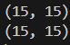
This was strange as I was certain that both matrices were 15x15. So I added some code to check the size of the input matrix and weights before running it again yet now it functioned completely fine.
Desperate to recreate the error, I continued attempts and managed to get the same error again.
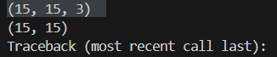
this happened only if the matrix chosen was in the folder for 9’s and somehow had 3 dimensions.
I assumed this had to be something with RGB as that would triple the size of the matrix so I tried printing the matrix right after it turned grayscale. I managed to see that it was indeed kept at 3 dimensions directly after being turned grayscale.
I then decided to print the shape before being turned grayscale

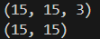
It appeared that being turned grayscale had not actually changed the size of the array. I decided to research the line of code that I was using to turn the image grayscale. i found online little about how the function actually worked, but I did see that people were using image = image.convert(“L”) instead of just image.convert(“L”). I implemented that and the problem was fixed.

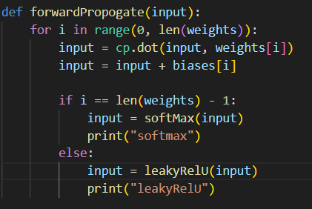
After fixing that, I could now move onto adding the activation functions. I removed all code that I used for testing and added if statements to choose which activation function would be used.
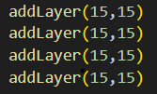
this was my initial code. I was unsure of whether I should be subtracting 1 from the len(weights) or not but decided to test it as is. I added 4 layers to test with. The expected output was 3 leaky Relus and 1 softmax

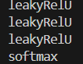

This worked first time thankfully. I now needed to add the function to flatten the array before softmax. i added the code and received an error but simply had to change the final layer to a 225x10 to ensure the dimensions lined up
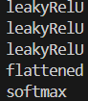
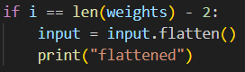

The output was perfectly as expected. I checked my research and realised I had finished off the function so I removed all print() statements and returned the final value. Before moving onto my loss() function
For loss, the formula that I would have to implement is:
-(correct answer * log(predicted answer))
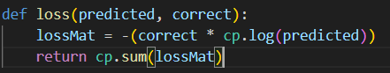

Which was simple enough as it was only maths to implement. I now wanted to test the function by comparing a real predicted result with a correct one, this would mean that I would have to add all functions I have made so far to the training loop.
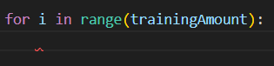
i started by adding a loop that will run the training the specified amount from the earlier input
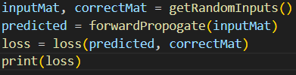
I could now just feed the functions into each other to create a full forward pass.

My first attempt went completely as expected - returning a suitable loss.

My second attempt however, returned an error.

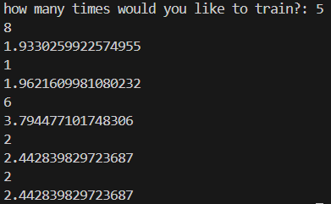
I assumed this was due to the function and the variable having the same name. I quickly changed the function to calculateLoss() instead
The function now works as expected. In this example, the top number represents the number that is in the image and the bottom number represents the loss. I wanted the network to also output the accuracy after a given number of attempts, so quickly implemented that.
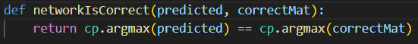

I started by making a function to check if the network is correct to ensure the section for training loops remained clean.

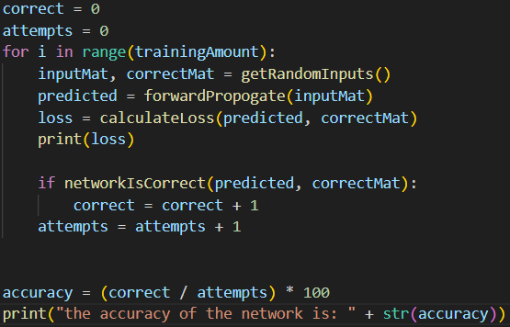

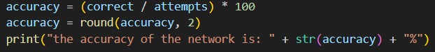
I disliked the appearance of the accuracy so decided to add a percentage mark and round it to two decimal places.

I could now move onto the backwards pass. I personally find that the most confusing part of backpropagation is calculating the deltas of each layer. So I decided to start with the delta() function to get it out of the way.
To ensure that I do not get confused or create any large errors, I will be following the design word for word
initialise an empty array called “Deltas”
compute the error of the output layer
append the error to Deltas
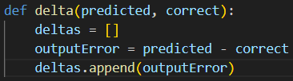
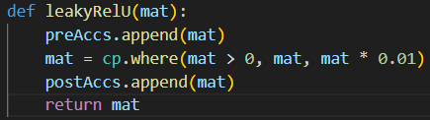
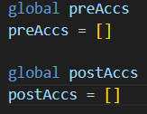
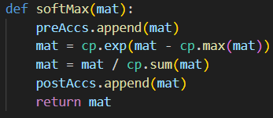
Before I continue on the function, I couldn’t help but notice that I needed an array for pre activations and post activations that I had forgotten to add to my program. I quickly implemented the arrays.

I also had to reset the arrays every training loop so I followed my research and reset them before appending the input matrix to postAccs
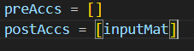

Now that that is out of the way, I could continue on the Delta() function.

start at the final layer that is not the output layer, moving back a layer each loop…
…repeat until the length of Delta equals the length of Weights
I figured this would probably be easier with a for loop instead of the previously planned while loop so implemented that instead

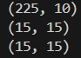
This loop should start at the final index of weights and move backwards until it reaches 0, yet I wasn’t sure and so decided to test by outputting each weight’s size.

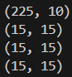
I found that it only outputted 3 of the 4 weights. Not outputting the first layer. I changed the loop to stop at -1 instead to see if that would work.

Now with the loop functioning. I could actually add the necessary calculations inside of the loop.
get the index of the weight in Weights using index()
get the corresponding pre activation result from that layer in preAccs
use the first term in the Deltas array as the delta of the next layer
compute the delta for the layer
insert the delta to the front of the Deltas array
since I was not using a while loop, I already had the index and so could change the first step to be the other way around, instead getting the weight from the index.
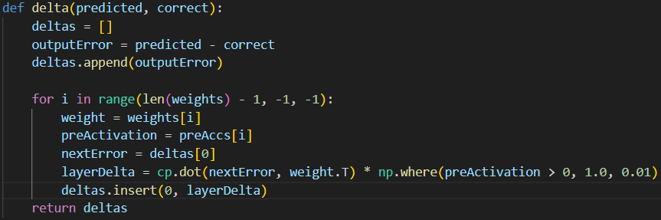
I then came across this error
I initially thought this mean that my weight had a shape of (1, 255) and my pre-activation had a shape of (1, 10). But this actually meant that the dot product of the next error and the transpose of the weight had a shape of (1, 255).
To fix the error, I would have to un-flatten the shape back to (15,15) and I would have to use the pre activation from the weight before in forward prop. This would give me a much nicer matchup of the axis.
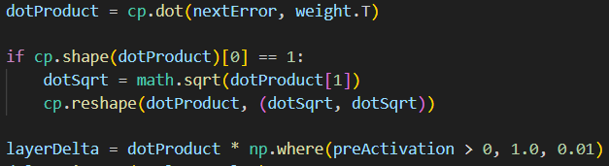

This was my first attempt, despite not being maintainable, it would work as a proof of concept by reshaping the matrix back to a square if it has been flattened from a square.

And then I only had to change this line of code to fix the pre activation problem. The code was now ready to be tested.
I immediately came across an error upon using dotProduct in place of cp.shape(dotProduct), this was quickly remedied

Next was this error
Which I received because the square root was still technically a float instead of being an integer. For this testing, I simply assumed that the square root would always be an integer and directly cast it.

I then had to directly change the way that dotProduct was reshaped. As I had not reassigned the value back to the matrix.
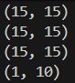
The function could now finally make it past the first loop, however it struggled with the first value in the preAccs array, which was unexpectedly shaped as a (1,10). However, upon checking the array, I could see that (1,10) was actually the final value. I decided to check the length of the deltas array and could see that it was the same length as the weights array, meaning no further error had to be calculated.
Although shaky, I was happy with the final result from the function. I now wanted to implement a much more consistent method of reshaping the matrix.
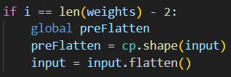
My plan was to set a variable called “preFlatten” to the size of the matrix when I flatten and then return to that size in backprop. I began by initialising it in forward prop.

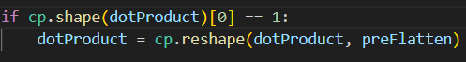

And now it could be set in backprop. With that addition, the function was now finished. I am however concerned of mathematical inaccuracies in the program
I could now move onto actually updating the layers, thus began work on the updateLayers() function
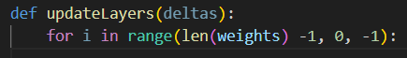

I began by creating the basic frame for the function alongside a loop to go through every weight. I tested it to ensure that it looped through every weight and similarly to the delta() function I had to change the stop point to -1 to ensure every weight was visited.
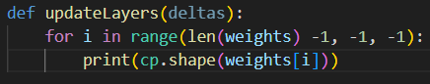

The steps that have to be taken inside the loop are:
get the index of the layer and then the corresponding post activation / delta at that index in their own arrays
calculate the change to the weights
subtract the change to the weights multiplied by the learning speed from the weights
sum up the delta array columns and subtract from the biases
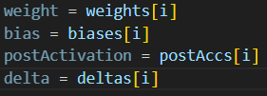
I started by filling variables of every value that I would need to make the following calculations much easier to follow.

Implementing the first calculation immediately gave an error. The post activation had a size of 15x15 and the delta had a size of 1x10

I believed that this was an issue with the flattening again because if I had a 225x1 and 1x10, the multiplication would immediately match up and create a 225x10 that I can subtract from my weights. I decided to change the forwardPropogate() function slightly, my plan was to remove the most recent term in post activations when the post activation is flattened and then append the flattened version instead
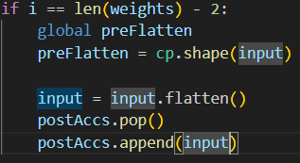

Yet this lead to the issue of having a post activation of size (225,) without a column value. So I decided to manually reshape to (rows,1)
This code then returned an error that I was implicitly converting from numpy, my first thought is that the flatten() function was a numpy function. But removing this gave me a new idea, I could instead just reshape to (225, 1) instead of flattening.
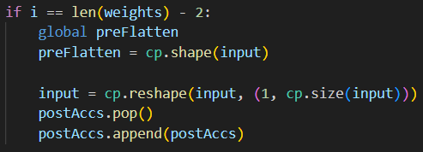
this code seemed to work, correctly getting through forward propagation. However I received another implicit cast error in updateLayers() now

I decided to check the type of the post activation to see why I was getting this error and was surprised to see it was a list.
My first thought was to turn the list into an array with cp.array()

However the code not would not run past this point for some reason. Freezing until the program just stopped even if I used cp.asarray() or np.array(), it simply would not work.
I then took a second look at the code to append the post activation, seeing the glaring error. I was appending the list to itself with postAccs.append(postAccs), I was not appending the input. Upon changing this, the network was able to complete a full run-through, I now needed to actually make the change to the weights and biases
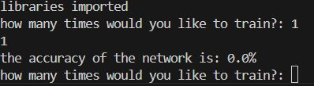

I now actually made the change to the weights
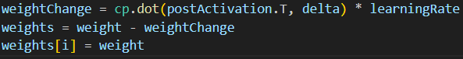

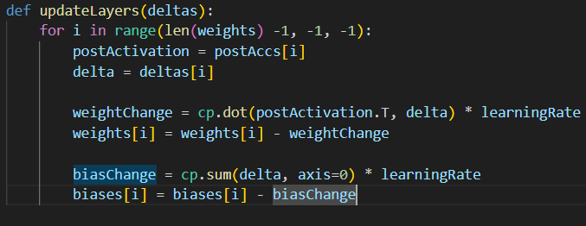
Although this code did work, It made me realize just how unnecessary the “weight” variable was, I removed both lines it was used and replaced weight with weights[i]. I then did the same for the “bias” variable.

And above is the finished function. With nothing else to add to the program for backprop, I decided to check through the design to ensure I had not forgotten something
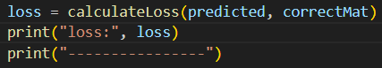

I added some output for the loss so that I can see if it is decreasing over time as is expected. And I also set the layers to what I originally planned in my research. I now tested by running the network 500 times and then an extra 100 to see the final accuracy.
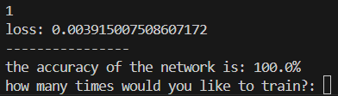

The network successfully reduced the loss of the network and increased in accuracy over time. Words could not describe how proud I was of this network. I also kept an eye on the GPU and it used a maximum of 1 GB throughout training out of a maximum of 7 GB. I then used layer sizes going up to 4000x4000 and the program did not go over 2 GB.
I decided to check the success criteria to see if I had forgotten to add anything. I was extremely relieved to see that I had not missed anything.
Now with this, my final programming implementation was done and i could move onto my final stage of the program, I would firstly like to review this implementation however to see how it was handled in comparison to the last one
review of implementation 2
implementation 2 was far more successful than implementation 1, the programming was much cleaner and without many errors and the research was much more thorough - ending up being incredibly useful whilst programming.
I did however struggle greatly with the maths, I am in year 12 for maths currently and although I can understand most formulas, the formulas online for backprop are on a whole other level from what I can currently read. This led to a reliance on my own notes that I have kept in the past, which did not go into enough detail after going so long without programming a neural network.
Deadlines were also a massive struggle in this implementation, I had not given myself even the slightest bit of wriggle room and ended up finishing the project on the 25th – 2 days after my planned finish. This is because I did not work on the project for 2 of the planned days. In the future I will most definitely give myself more time to complete projects in to ensure that my stress is kept to a minimum.
Now this statement may ring true for the whole project, but the risk assessment did not feel particularly strong. I was aware that it was extremely important in spiral methodologies, but the importance of risk assessment truly became apparent once actually placed into practice. Although my methods of countering the risks I mentioned did most definitely work, I did not give a thorough enough assessment and did not trust the assessment that I made – leading to errors in development. I also have not created a second risk assessment for implementation 2, even now I see that as unnecessary, but it would have undoubtedly been a good idea.
Despite these points, I am extremely proud of how I adapted after the first implementation and am assured of the importance of these projects and the education that they are giving me in software development
Cycle 3
Now, my original plan was to dedicate a final 5 days to a 3rd cycle where I would fine tune the network and find data for it to train on, yet I seriously doubt that this cycle would benefit my knowledge a great amount in terms of development. I also would not be able to commit enough time to it after running my deadline of the 2nd implementation. I am therefore happy leaving my project where it is as a proof of concept that I have learned a large amount from.
Conclusion
I’d firstly like to discuss the choice of spiral and how It changed the development of this project by so incredibly much. I have already described spiral earlier in this document but the definition given was one stripped directly from mark schemes and textbooks on computer science. I truly believe that I can now understand why spiral has the advantages and disadvantages that it does. A poor risk assessment would lead to unnecessary choices in the project and the project can easily take up much more time than planned, however, the quality of the end product is reassured as you must plan exactly what you want in the design phase and follow it to a tee with flexibility that allows for easier changes than other choices. I am extremely content with the choice of spiral and would likely use it for future personal projects that I make. It should also be noted that I enjoyed this methodology much more than I would’ve thought, it did require a large amount of writing yet that writing made the programming so much simpler and more enjoyable.
If there was a single thing that this project has taught me, it would be the importance of planning, but just as equally adhering to that plan. Rushing a plan for a project will only lead to a tricker development and more issues in the future, and not planning a project at all gives no guarantee of the end result. When I say adhering to that plan, I both mean sticking to rules such as a risk assessment and sticking to deadlines that you make. Just as equally, your risk assessment must be thoroughly planned and your deadlines well designed.
To keep it short and sweet, project development is about building trust with yourself – trust that your past self has planned things out for you well enough and that your future self will stick to the rules that have been set. It is also about building understanding; understanding of what you need when you are in the implementation phase and how to display that information in the most effective way possible to reduce stress and increase ease of programming. I am sure that this would be just as equally prevalent in a team environment, where you must understand others in such a similar way.
So what will the future of this methodologies study hold? Well, once this document and my finished work folders are placed on GitHub, I will be taking a break from programming for a while and working on other life obligations. Then, I will come back to this study with a new project – one that focuses on physics. The current plan will be to use my understanding of physics and mechanics in maths to create a simulation. What will that simulation be? I am currently not certain, but only time will tell.
I do sincerely hope that anyone who has decided to read through this document has found the experience intriguing and not too wordy – understanding more about themselves in the process. With that, I will be taking my leave…
See you in the next project!

